Appendix F: Equations for the BUSH element
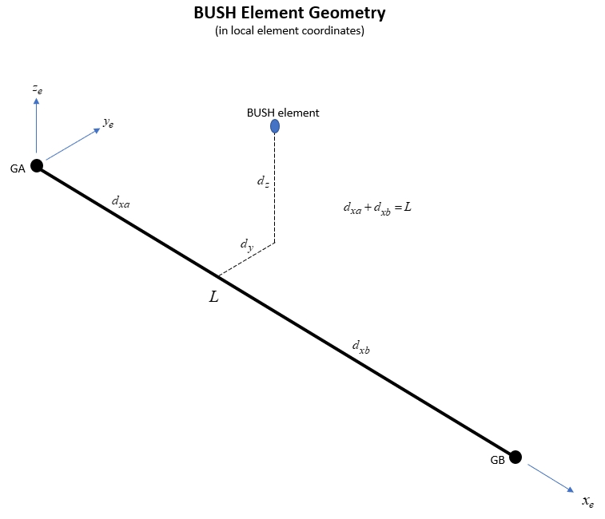
The stiffness equations for the BUSH element can be expressed as:

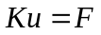

where  is a 12x12 matrix and 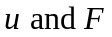 are the 12 degree of freedom (6 at each of the 2 grids) displacements and node forces. For the sake of clarity, rather than showing the whole 12x12 stiffness matrix, express the above equation in grid partitioned form as:

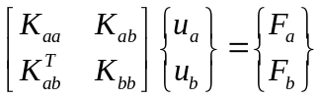

If we denote 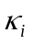(i=1,…6) as the 6 stiffness values from the PBUSH Bulk Data entry then the above partitions are:

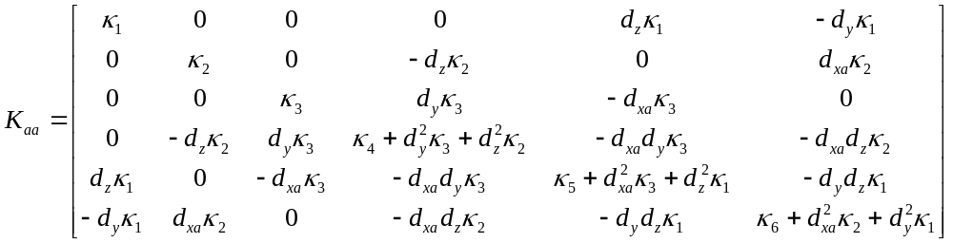

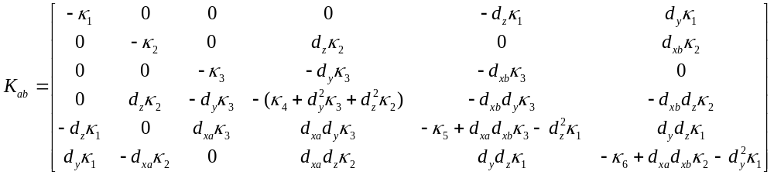

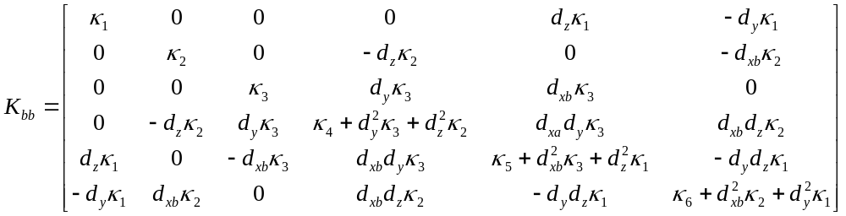

An image of the full 12x12 matrix with the above partitions is shown below:

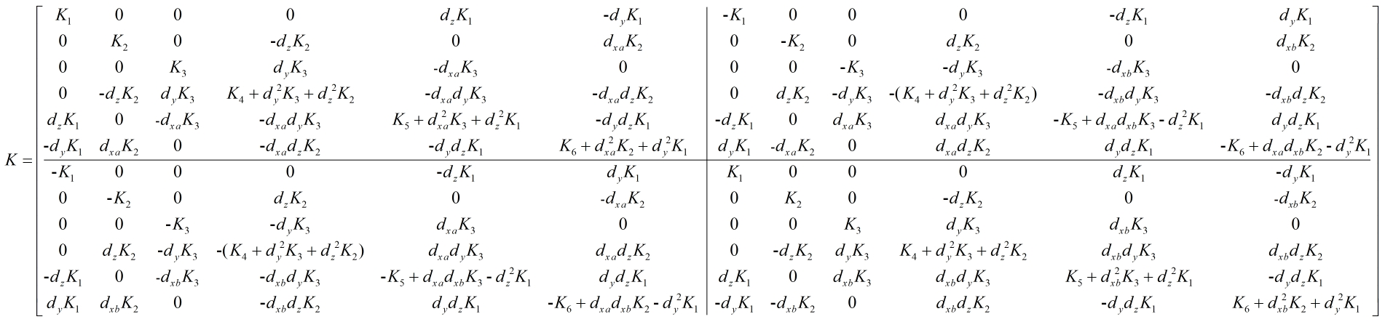

Note that the partitions 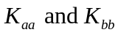 are symmetric
The element engineering forces can be derived using the figure below:

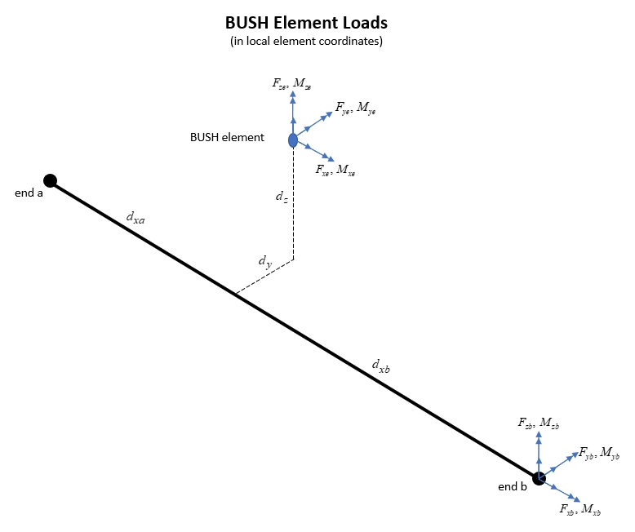
The engineering forces in the BUSH element are:

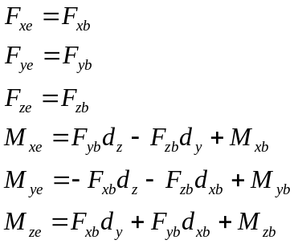

This can be put into a form which includes all nodal forces as:
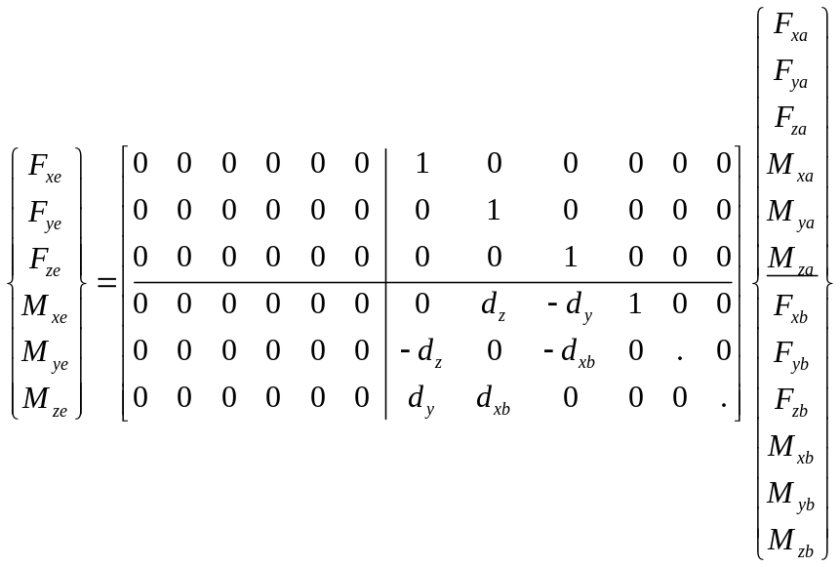

The 6x12 transformation matrix in the above equation is used in the MYSTRAN code to transform the element nodal forces to element engineering forces
The engineering forces in the BUSH element are:

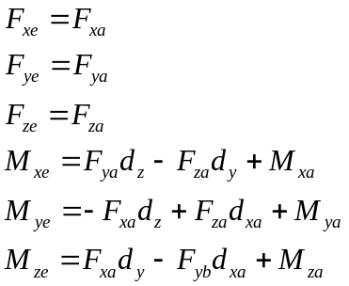

This can be put into a form which includes all nodal forces as:

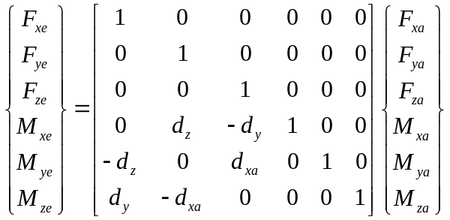

The 6x transformation matrix in the above equation is used in the MYSTRAN code to transform the element nodal forces to element engineering forces

